



UK SMEs - Smart Cities Solutions Challenge

An invitation for UK SMEs to submit smart city proposals for deployment across Chinese cities.

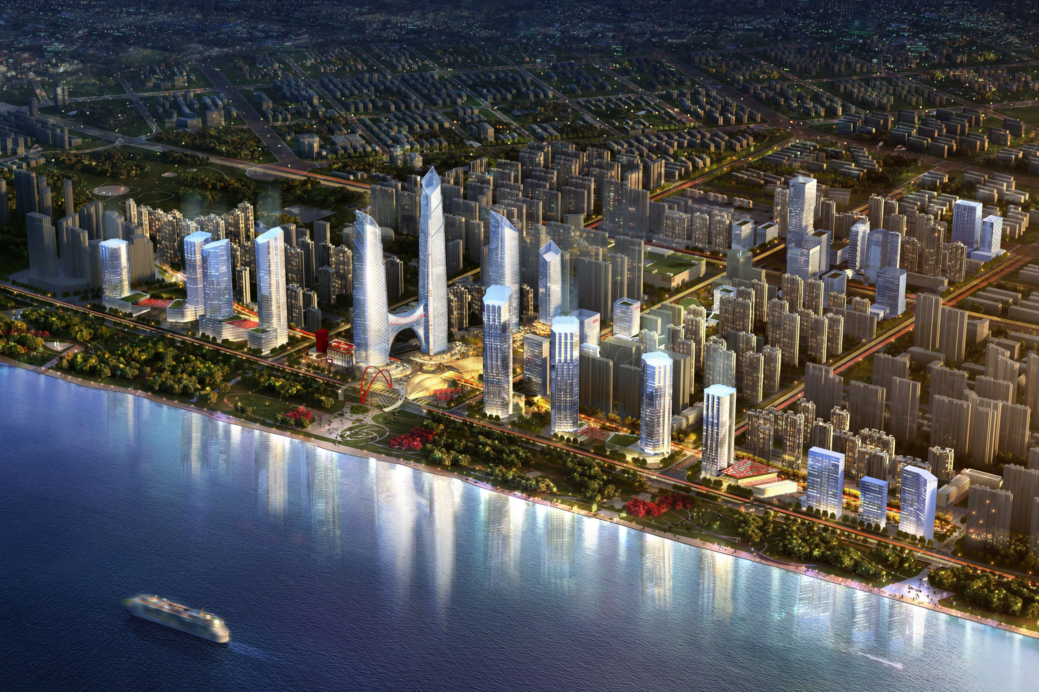

UK SMEs - Smart Cities Solutions Challenge

The UK China smart cities project is seeking to establish a strong relationship with a small number of SMEs working in the smart cities market. Our aim is to identify and deliver smart city solutions that overcome the challenges faced by Chinese cities, whilst at the same time opening up markets to UK business.

Introduction

The UK-China Smart Green Cities: Planning and Governance project is a joint initiative funded by the Foreign and Commonwealth Office and involving a number of UK and Chinese partners. Led by the city of Manchester it includes the cities of Bristol, Wuhan, Xuzhou and Quingdao as well as Digital China.

One of the key aims of this project is to introduce UK SMEs to the Chinese smart city market, worth billions of pounds in totality.

Background and Summary

Cities are growing at a breathtaking pace worldwide and the figures are startling. In 2008, the number of people living in urban areas worldwide rose above 50% for the first time, and will rise to 70% by 2050. Using these estimates, the world’s urban population will reach 5 billion by 2030. Worldwide, 476 cities have more than one million people living in them today, by 2020 China alone will have 221 cities with a population over a million.

This urbanisation trend is creating huge challenges for city leaders and managers, who will have to greatly expand municipal infrastructures if their cities are to accommodate and respond to the growing competitive pressure to attract and retain top talent and businesses in the face of increasing globalisation. Older cities, including all of those in the developed world will have, quite literally, to be comprehensively retrofitted. It has been estimated that the world’s cities will have to spend £17 trillion over the next 25 years to modernise and expand their infrastructures to remain competitive. This level of investment will drive a substantive global market for smart city solutions; by 2030, it is estimated that by 2020 this global market will be $408 billion pa. At the same time cities increasingly need to be able to do more with less, to compete in a globally-interconnected economy, to provide for the well-being of their citizens efficiently whilst balancing tight budgets and at the same time reducing their carbon emissions and energy consumption levels. Having the right levers and tools in place to enable us to turn our world leading research strengths into commercial propositions that will generate wealth and jobs and help us retain our place internationally will be critical to success.

The Challenge

Following workshops in July and October with the main consortia partners the following challenge areas have been identified for which we are seeking solutions across one or more of the following areas:

- open data standards and approaches

The rapid proliferation of sensing devices either fixed or remote are driving a rapid increase in the volumes of data collected. The collection, but more critically the analysis and interpretation of this data presents significant opportunities, but also a series of challenges to Chinese cities.

- securing private sector expertise and involvement in smart city projects

The smart city agenda relies on a degree of integration not just across different city systems (energy, transport and water fro example) but also between different organisations. Individually, single organisations have limited ability to deliver the smart city agenda, however in collaboration a multi-sector approach has significant benefit in bringing together delivery agents, enabler, innovators, research and statutory bodies.

- increasing knowledge and education amongst citizens

Citizens need to be at the heart of smart cities, not only as the users of technologies but where new innovations and ideas are generated. It is important that a bottom up approach is developed to influence the design of the smart city through a process of co-design so that the issues which affect them are addressed directly. The design of platforms and systems which allow them to participate is a critical foundation for increasing knowledge and education

- design and delivery of smart city districts

With delivery of smart city solutions being increasingly focussed upon cities, there is a need to deliver solutions in an integrated way rather than a silo approach. The identification of demonstration sites provides the opportunity to test at scale different approaches and solutions. These demonstrators could look at a variety of infrastructure and assets, which are integrated; this could include those around energy – its generation, supply, storage and use linked with the refurbishment and occupancy of buildings as well as the deployment of electric vehicles all within a wider ICT platform.

- development of city based integrated operations systems.

For Smart Cities, knowledge management is vital to ensure the consistent delivery of high quality services, to provide the capability to respond and react to events and to allow the city to predict, plan and develop its future. A number of cities have implemented or have plans for city wide operation systems. These systems can generate a number of benefits summarised as follows:
- strategic long term investment decisions around infrastructure that achieve environmental, economic and social targets in a balanced way,
- real time decision making with regard the operational management of critical city systems; and
- stimulation of economic activity through open access
What we want to achieve

We want to go over and above the usual trade delegation format and develop a more bottom-up co-designed model for smart city solutions, products and services addressing the specific challenges faced by Chinese cities. This collaborative approach between UK and Chinese cities is aimed at developing at close quarter an understanding of the challenges faced by cities and developing joint solutions to these through workshops in the UK and China.

Specifically we are seeking to identify and develop

- 10 x bespoke solutions to the challenges faced by Chinese cities, around which we will jointly work up into funding propositions by June 30th 2015
- 8 x examples of existing good practice or products and services which can be adopted as ‘quick wins’ within the Chinese market.

The Prize

We are not offering a cash prize. We want to be a little smarter than that. The selected businesses would be able to access the opportunity to;

- participate and discuss their solutions with high level officials from the cities Wuhan, Xuzhou and Quingdao as well as Digital China in the week of February 2-6th 2015, including an invitation to the official dinner
- be invovled in the final workshop in Wuhan during the week of March 23rd 2015 to further develop ideas and relationships, timed to co-incide with the official opening of the new UK Consulate General
- be involved in the development and co-design of projects within an expected Phase 2 to the project

In addition, there is the opportunity to become involved in the new EU China Smart Cities Forum, which Manchester is a leading city providing further market penetration and access to business opportunity.

Deadline

We require that you submit your proposition to us no later than Friday 17.00 GMT on Friday January 2nd

Decision

A joint panel will be established to assess the submissions consisting of key representatives from the project partners as well as UKTI. Shortlisted businesses will be invited to present their proposition to the judging panel during the week of February 2-6th.
Structure of Submission Form

We invite SMEs to present their proposals in the format set out below. You may choose whether you wish to submit under one or both categories making sure these are clearly referenced and labelled. In your proposition please make clear which of the 5 x challenge areas you are addressing.

Category 1: ‘Development Projects’. These are potential demonstration projects, which require a level of development and testing in a real life setting. Projects do not need to be fully worked up but need to demonstrate potential impact across Chinese cities as well as indicating a willingness to collaborate with Chinese partners in their design, development and deployment.

Category 2: ‘Quick Win’ projects. These should be previously tested and proven solutions that can be adopted within a relatively short-time frame within the Chinese market. Proposals need to show the impacts which these have had and how they could potentially be rolled out across Chinese cities.

In setting out the above applicants are encouraged to demonstrate potential impact and benefit. At this stage we are not looking for fully designed ideas and solutions and associated arrangements for deployment, these will be worked up in collaboration with Chinese partners, with Digital China playing a central role in this process.

All proposals should be set out in A4 format covering the following six areas.

- Name and Address of Business

- Name and Contact details of key individual

- Size and turnover of company

- Brief description of company and activity (no more than 150 words)

- Category 1: Description of Development Project (each one no more than 2 x sides A4 including diagrams)

- Category 2: Description of best practice for ‘Quick Win’ (each one no more than 2 x sides A4 including diagrams)

Please send all submissions by email to:

Steve Turner, Head of Future Cities, Manchester City Council
s.turner2@manchester.gov.uk

Further details of the project can be found on the website
www.uk-chinasmartcities.com

