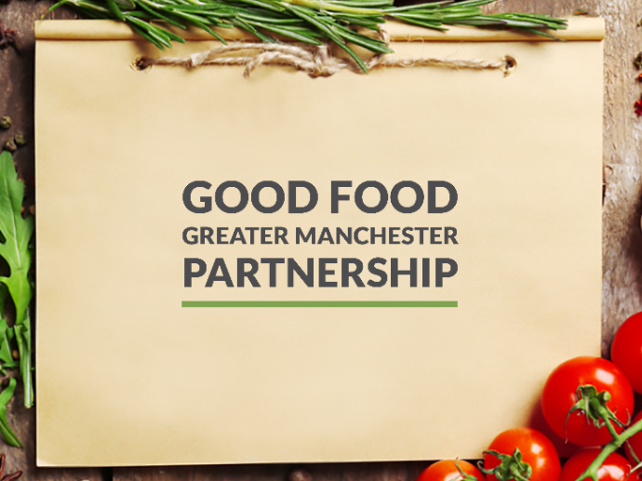

Join us and become a Champion for Good Food in Greater Manchester

Good Food Greater Manchester is the official food policy board for Greater Manchester. We are a multi-stakeholder forum that focuses on the following key objectives:

- Promoting healthy and sustainable food to the public.
- Tackling food poverty, diet-related ill health and access to healthy food.
- Building community food knowledge, skills, resources and projects.
- Promoting a vibrant and diverse sustainable food economy.
- Transforming catering and food procurement.
- Reducing waste and the ecological footprint of the food system.
Over the next few months, we will be embarking on a strategy development process, working with a wide range of stakeholders and building on the great work already being done in the region.
If you would like to be involved in this process, or be informed of developments, please fill out your details below and let us know any particular interests.
Name:
Address
Phone:
E-mail:
Are you interested in any of the specific objectives above, or other aspects of good food?

I agree to information relating to my information being stored in a computerised database in line with GDPR.

Signed: …………………………………………………………………… Date: ………………………………….

